**Exercise 1**

Create a basic WPF application to maintain a list of expenses incurred. Each expense will have the following attributes:

* expense category (one of 'Travel', 'Entertainment' or 'Office')
* cost (must be 1 cent or more to max of €100)
* date incurred (must be date in previous month)

Your UI should show a list of Expenses. A button at the bottom of the screen will add another Expense. Use a ListBox to show the expenses on screen and each expense should be displayed similar to this:

Travel: €23.35 on 3/8/2013

The ListBox should be pre-populated with a handful of Expenses on program startup. As such, these Expenses must be auto-generated randomly. This obviates the need for the user to enter any data.

At the bottom of the screen, provide a total for all Expenses beside the button to add another.

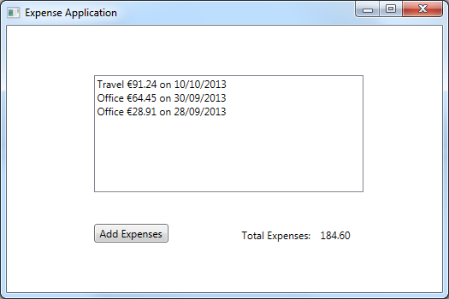

**Exercise 2 (No video – try it yourself)**

Create an application which displays member information for a club as shown below.

You will need to create the XAML interface as per the screenshot with a Listbox on the left, and a number of elements on the right -combobox, textbox, date picker and button.

Member class has the following properties

* Member Name
* Membership type – Full/Off Peak/Student/OAP.
* Date Joined

Use Random to generate the year the user joined between 2000 and 2015.

Note – there is no SelectionChanged event handler as all the member info is displayed in the listbox.

